**Unit: Manual Motor Controls Quiz: 6**

**Motor Nameplates and Three Phase Motors CLO#: 1**

Name ______________________________ Date ______________

**Instructions**

Select the best answer for each multiple-choice question below.

1. Which component of a three-phase motor produces the mechanical energy?
2. A motor’s RPM rating is determined when;
3. What is the purpose of the laminated iron plates within the rotor?
4. Most industrial motors are of what type?
5. List three general types of three-phase motors.
6. If an application requires 1.1 horsepower, it is better to purchase a 1HP motor with a SF of 1.25 than to purchase a 1.5HP with a SF of 1.0.
   1. True
   2. False
7. What does FLA indicate?
8. Why would it be good the select a motor that has a SF > 1?
9. What is motor slip?
10. What is the effect of operating a motor above its HP but within its SF?
11. What is motor Efficiency?
12. When a motor is rated for inverter duty, what does that indicate?
13. All manufactures follow the NEMA guidelines when designing their motor nameplates.
    1. True
    2. False
14. If a motor is not continuous duty, it is designated as?
15. When a motor’s nameplate lists AMPS, what does that designate?
16. A motor has a *Type*. What does this signify?
17. A motors *Power Factor (PF)* is useful to determine

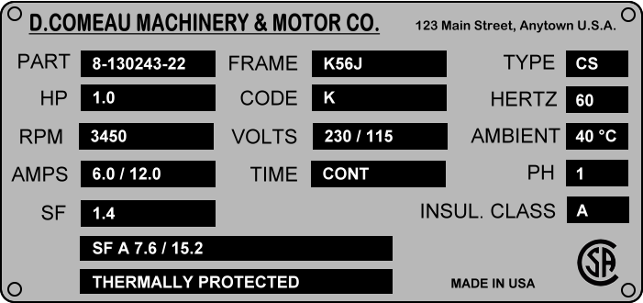

1. What is the horsepower for this motor? __________
2. How many watts should this motor dissipate? ______________
3. What nominal voltage level would you use to connect to this motor to its higher low-voltage setting? ___________
4. What is the acceptable range of voltage input to this motor connected to that voltage range? _______ to _______
5. What is the RPM for this motor? ____________
6. Based on the above RPM, how many poles would this motor have? _______
7. What is its percentage slip? __________
8. What is the service factor of this motor? __________
9. What is the maximum horsepower output of this motor? _________
10. It is safe to run this motor at its max HP for extended periods of time.
    1. True
    2. False
11. Draw a schematic to the right of the motor contactor that indicates its internal components.



1. Construct the formulas for the control schematic below. HINT: There shall be separate formulas for M1 and the red light. (M1 and green light formulas are the same)



1. If a motor has an enclosure type of ODP, what does that indicate?